|  |
| --- |
| **David’s Communication Passport** |
|  |
| By David Leah, ICE Resource Assistant |
|  |
|  |
|  |

|  |
| --- |
|  |

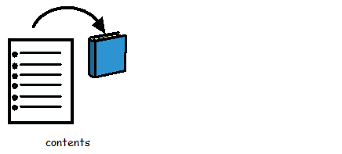Contents Page

|  |  |
| --- | --- |
| Page 3 | Things you should know about me |
| Page 4 | Asperger’s Syndrome |
| Page 5 | Misunderstanding Idioms |
| Page 6 | Childhood |
| Page 7 | Identifying my Surroundings |
| Page 8 | Building Models of Cities |
| Page 9 | Growing Up |
| Page 10 | How I Communicate |
| Page 11-12 | My Communication: Dos and Don’ts |
| Page 13-14 | What I like to talk about |
| Page 15 | Facial Expressions |
| Page 16 | Meeting New People |
| Page 17 | Responding to Questions |
| Page 18 | Food and Drink |
| Page 19 | Contact Details |
|  |  |

Things you should know about me

Name and birthday

My name is David Charles Stephen Leah. I was born on the 15th September 1988.

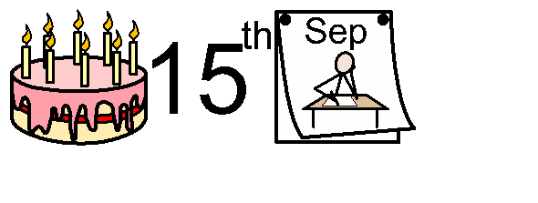

My job

I work at Witham Library for ICE Resources. ICE stands for…



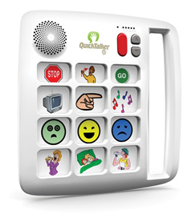

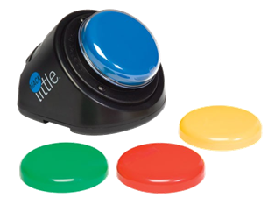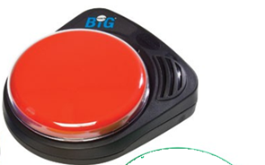We offer out special equipment for adults and children with communication difficulties.

I have Asperger’s Syndrome. This is a mild form of autism.

This means I may have some communication difficulties.



**Emotions**

I mostly find it difficult to understand other people’s emotions. I can’t read people’s faces very well.



Facial expressions are not 2D, and it’s sometimes difficult to identify.

How do I know if my boss (pictured right) is really smiling? He could be disguising his anger after I accidently spilt coffee on his desk.

**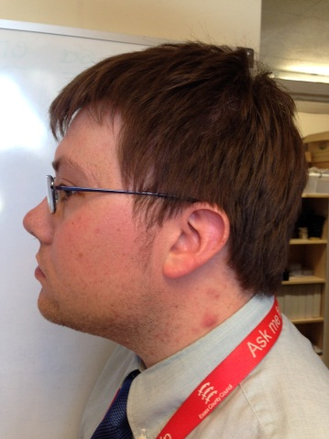**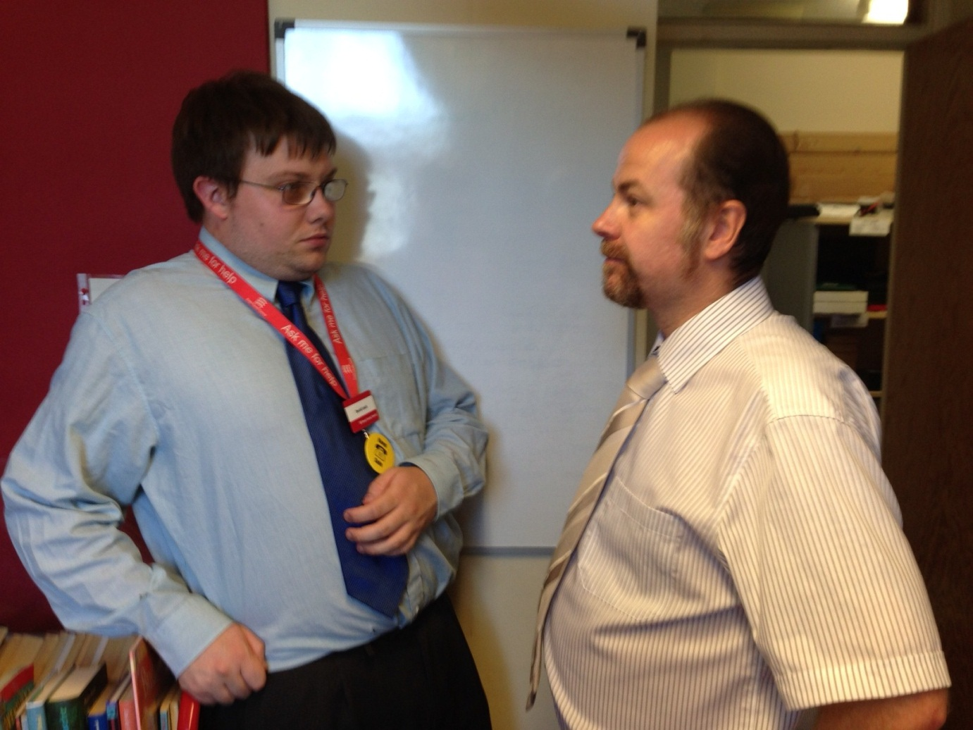

There’s a difference between my perception and the other man’s emotions.

**Misunderstanding Idioms**

This was common when I was young. People would say things that seemed to make no sense whatsoever.



Looks like Granddad’s got his head stuck in the television.

**Childhood**

From a young age it was obvious that I was different.

I just couldn’t understand other people and their fancy words.

I had difficulty interacting with other children.

At times it felt like I was observing people from behind a sheet of glass.

It took me a while to interact with other kids.

So I spent time creating my own little world. You’d catch me doing silly stuff like this...

**Identifying my surroundings**

Having Asperger’s can be frustrating. But it can also be interesting. I was always curious about my surroundings.

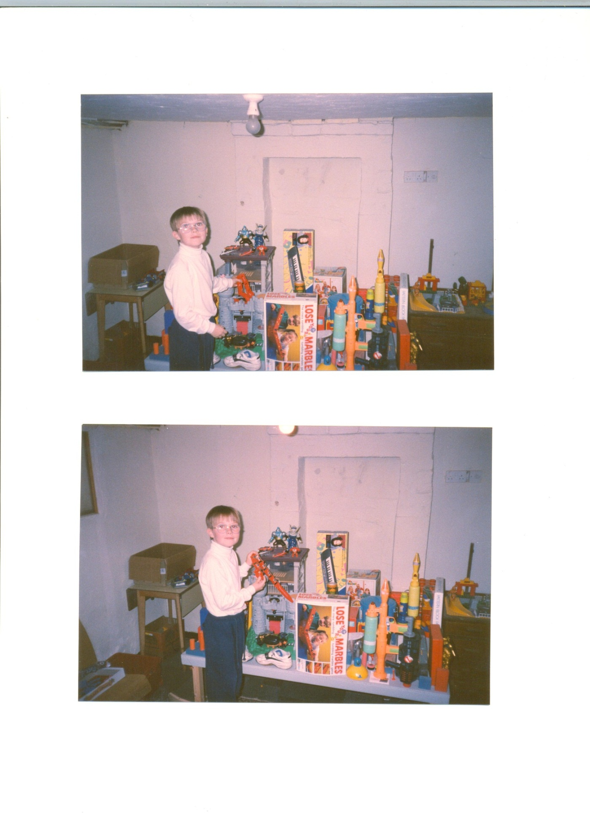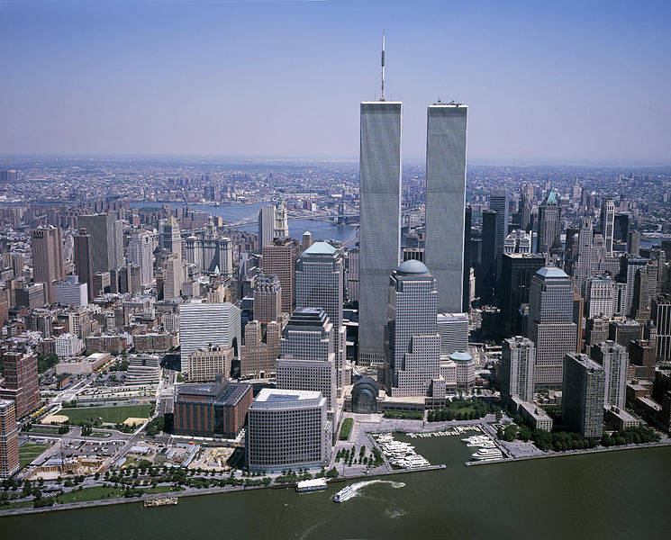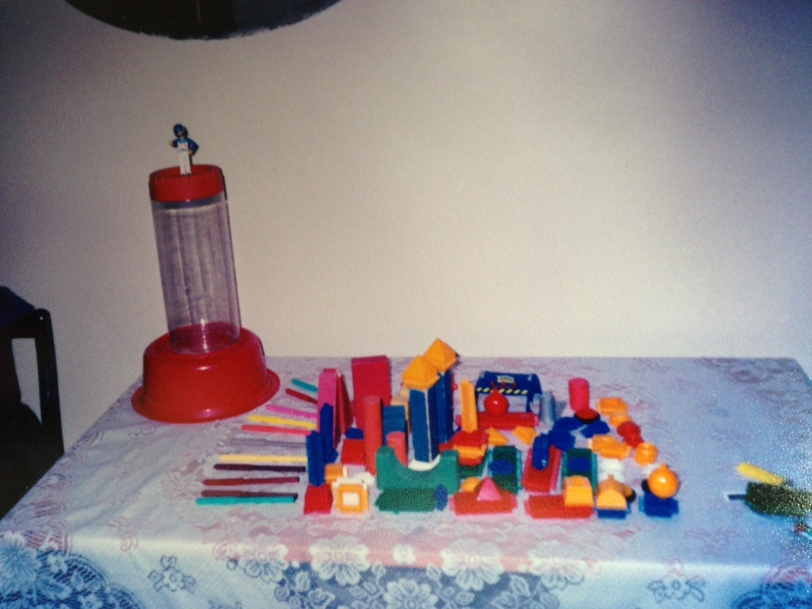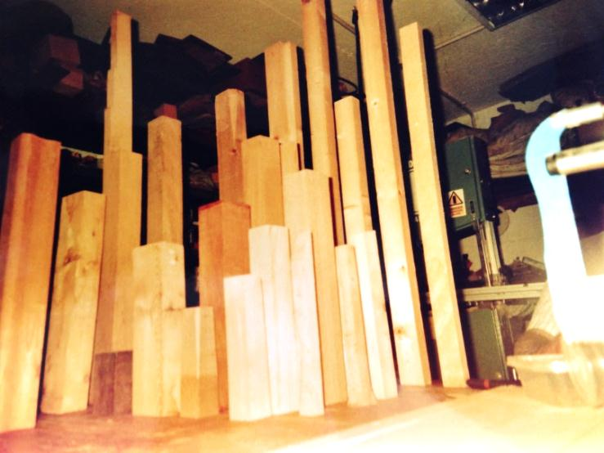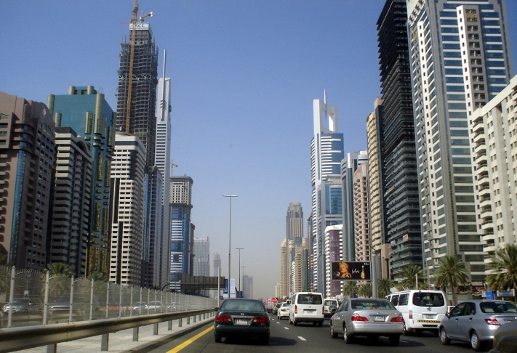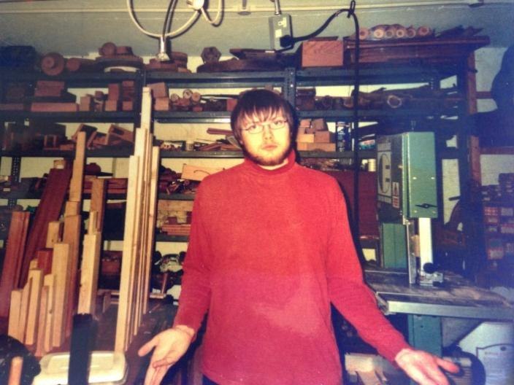**Building models of cities**

Continues on next page…

Back at home, I built a city model using toys and boxes.

At Dungeness I was fascinated by the size of the power station, the lighthouse and all the pylons.

As a kid, I’d go on holiday with my family. We went to places like Dungeness in Kent.

I’d use any spare resources.

I saw photos of New York City skyscrapers.

So too did my resources.

Over time my perspective developed…

By the way, I’ve never been to New York or Dubai… yet.

Growing up

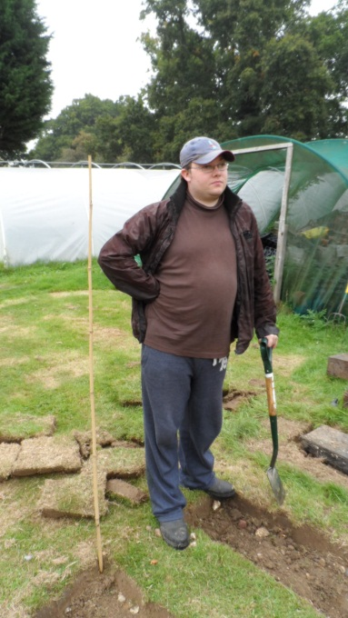



In 2013 I joined the ICE team. I now help deliver a service to other disabled children and adults.

I even went to university and gained a degree in English.

I got to work voluntary at Roundwood Garden Centre.

It’s thanks to my brother that I can interact with people.

I had plenty of support at school.

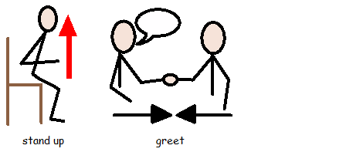How I communicate

If someone visits me at work, I may stand up and greet you with a handshake.

I’ll put my hand up if I wish to speak

I speak as fluently as possible, and listen to what the speaker has to say (if they can keep my attention).

I can use low-tech communication tools.

TickMy communication: dos and don’ts

big red cross image

**Please Don’t**

**Please Do**

big red cross imageTick

Make lots of noise.

I can’t concentrate.

Put your hand up if you need to speak

Get the report done, but in a this format, and add the intro…



big red cross image

David, could you please write this out in font size 14

big red cross imageTick

Give me too much information.

Speak at a pace I can follow

Continues on next page…big red cross imageTickTickTick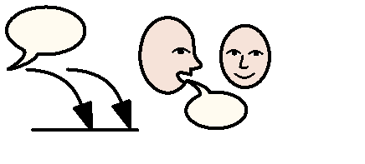big red cross imagebig red cross imageTickThings I like to talk about:

That’s a bad idea, David

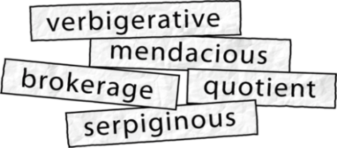

Talk jargon



Snap your fingers at me

Relax.

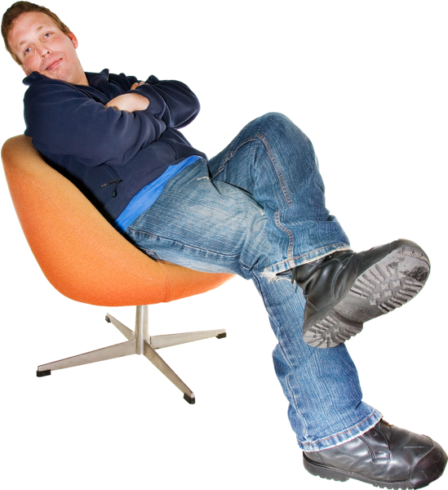

Feel free to disagree



Ask me to repeat myself if you can’t hear me

Step into my personal space

**Please Don’t**

**Please Do**

Continues on next page…

Horror Movies

Comedy shows

Heavy Metal

Anything scary or weird

Cute and funny animals

…and that includes hyenas ☺

Favourite shows

Game of Thrones

Doctor Who

Hobbies

Especially anything scary or weird…

I love reading about anything to do with the supernatural.

I love writing stories and plays…

Facial Expressions

My expressions can be hard to verify…

By the way, I don’t normally look this smug.

I was asked to smile for the camera.

I never smile, not unless you tell me something really funny.

At times I may appear to be blank, as if I’m lacking a sense of humour.

I **do** have a sense of humour. I’m just very nervous around strangers and new surroundings.

I’ll be as polite as possible.

You’ll just have to forgive me for being awkward at times.

Meeting new people

If I’m sitting down, I’ll stand up to greet you.

I’ll always shake your hand when approached.

I’ll always open the door for anyone (especially ladies).

Sometimes I may even appear to bow.

Responding to questions

Hmm! Let me think about this…

What do you need for Sharing Day?

If you ask me a question I may not reply straight away.

Don’t worry. I will answer you in a minute.

While you’re at it, don’t forget…

David, can you…



Just don’t ask me too many questions at once. I’ll just get confused.

I take my time thinking through my answers. This is my **thinking time**.

Food & Drink

|  |  |
| --- | --- |
| **Like** | **Don’t like** |
| C:\Users\David.Leah\AppData\Local\Microsoft\Windows\Temporary Internet Files\Low\Content.IE5\LB8A9OQW\Steak_and_Chips[1].pngSteak & chips  - medium to well-done | C:\Users\David.Leah\AppData\Local\Microsoft\Windows\Temporary Internet Files\Content.IE5\CFBETBED\MP900439317[1].jpgLamb:  - I refuse to eat baby animals ☹ |
| C:\Users\David.Leah\AppData\Local\Microsoft\Windows\Temporary Internet Files\Content.IE5\1PWMV6AW\MP900182719[1].jpgAnything with  Fried chicken | C:\Users\David.Leah\AppData\Local\Microsoft\Windows\Temporary Internet Files\Low\Content.IE5\QLJICUZV\Chop_Mash_Peas[1].pngMash potato  \\chesfs50\EUCHomedirs\David.Leah\My Documents\My Pictures\Circle answer.gif- never liked the texture |
| [File:Homemade chicken tikka masala.jpg](http://upload.wikimedia.org/wikipedia/commons/6/61/Homemade_chicken_tikka_masala.jpg)Curry | C:\Users\David.Leah\AppData\Local\Microsoft\Windows\Temporary Internet Files\Low\Content.IE5\QLJICUZV\Wine[1].pngC:\Users\David.Leah\AppData\Local\Microsoft\Windows\Temporary Internet Files\Low\Content.IE5\W1BUFVM8\Beer-Can[1].pngAlcohol |
| C:\Users\David.Leah\AppData\Local\Microsoft\Windows\Temporary Internet Files\Low\Content.IE5\W1BUFVM8\Bread_Roll[1].pngCrusty bread | C:\Users\David.Leah\AppData\Local\Microsoft\Windows\Temporary Internet Files\Low\Content.IE5\BXOPQQAW\Burger[1].pngCheeseburgers – too much cheese |
| C:\Users\David.Leah\AppData\Local\Microsoft\Windows\Temporary Internet Files\Low\Content.IE5\W1BUFVM8\Salad[2].pngSalad  - especially with dressing | http://alittlesmackerel.typepad.com/.a/6a0115706bd14f970b0120a5623025970c-800wiCustard – it has a yucky texture |
| C:\Users\David.Leah\AppData\Local\Microsoft\Windows\Temporary Internet Files\Low\Content.IE5\W1BUFVM8\Pizza[1].pngPepperoni Pizza  - not too cheesy | C:\Users\David.Leah\AppData\Local\Microsoft\Windows\Temporary Internet Files\Content.IE5\NZJ4037T\MC900431563[1].pngCoffee |

Contact details:



|  |  |
| --- | --- |
|  | Telephone: 01376 519 625 |
|  | Email address:  [David.Leah@essex.gov.uk](mailto:David.Leah@essex.gov.uk) |
| C:\Users\David.Leah\AppData\Local\Microsoft\Windows\Temporary Internet Files\Low\Content.IE5\QLJICUZV\Envelope_write[1].png | Witham Library  18 Newland Street  Witham, Essex  CM7 2AQ |



Special thanks to my family, friends and colleagues at Roundwood Garden Centre and Witham Library.

Date: April 2015

Made using PhotoSymbol Cloud and Communicate-in-Print2